Student Cohorts in Workday

Cohort Overview & Considerations
Types of Workday Student Cohorts
Reporting Considerations
Create Cohort Types and Cohort Collections
Create a Manual Student Cohort and Assign Advisors
Create a Criteria-Based Cohort
Extend Indexed Data Sources
Add Student to Cohort
Add Multiple Students to a Cohort
Remove Student from Cohort
Remove Multiple Students from Cohort

Cohort Overview & Considerations
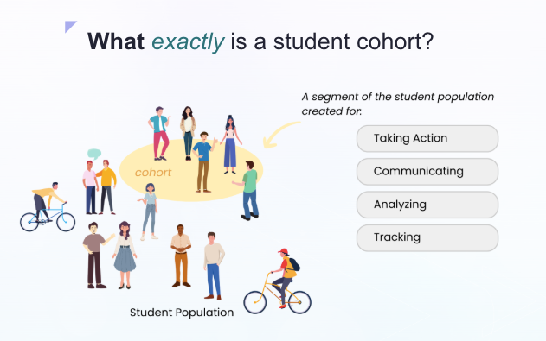
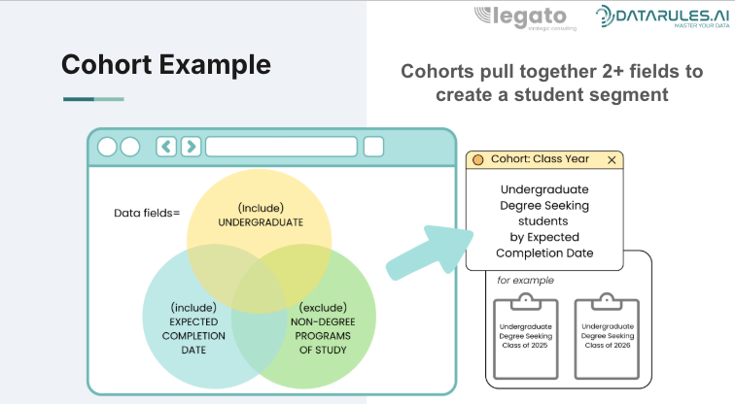
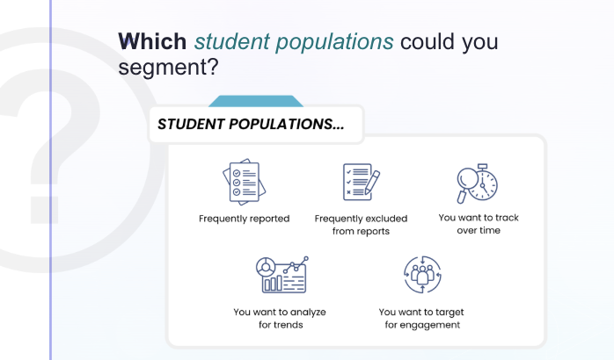
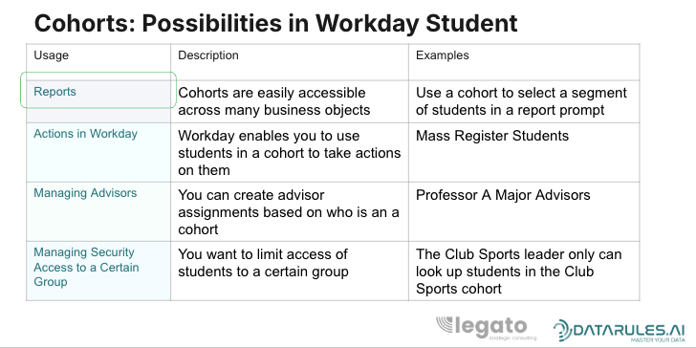

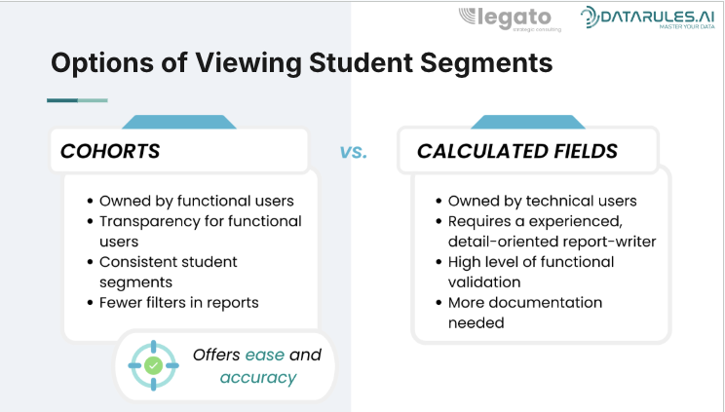

Before you create a cohort, have a strategy in mind.
- Which student segments do you have to regularly remove from reports?
- Which students do you regularly use in reports?
- Which students do your leaders want to know about?
- Do you want to track a student segment over time to discover trends?
- Do you want to target a student segment for an engagement plan?

Types of Workday Student Cohorts
Manual Cohorts
Manual cohorts require students to be explicitly added or removed by users. Manual cohorts are best suited for populations that require direct oversight or do not have reliable system-based criteria. Students can be added using the following methods:
- Add Student to Cohort task
- EIB: Load cohort membership using an Excel file
- Integration: Automated data loads from external systems
- Mass Action: Available from the Find Academic Records report

Criteria-Based Cohorts
Criteria-based cohorts automatically add or remove students based on defined rules within an associated report. This report must:
- Use the Academic Records data source and business object
- Be performance optimized
- Use indexed fields
Although it is technically possible to manually add or remove students from a criteria-based cohort, this should be treated as a last resort. If a student is not being included or excluded as expected, the underlying report should be reviewed and validated first. Once a manual override is applied, that student’s cohort membership must be managed manually going forward and will no longer fully align with the report logic.
Important: There is currently no security setting that restricts manual overrides. Any user with edit access to the cohort can manually add or remove students.
Criteria-based cohorts are refreshed nightly. A manual refresh can also be performed as needed, particularly after changes are made to student records.
If a field is not available for a criteria-based report because it is not indexed, there is an option to extend it (essentially making it indexed/available for use). To do so, see Extend Indexed Data Sources.
Example Cohort Use Case 1:
- Cohort Name: First-Year Students
- Cohort Purpose: Basic Identification
- Criteria:
  - Class Standing: Freshman
  - Program of Study Status: Not in Completed, Discontinued, Institutional Withdrawal
- Reporting Features:
  - Provides basic demographic data for newly enrolled students.
  - Used to supply general orientation information.

Example Cohort Use Case 2:
- Cohort Name: Veteran and Military Students
- Cohort Purpose: Targeted Reporting and Data Collection
- Criteria:
  - Student Attribute: Veteran or Active Military
  - Load Status: Full-Time or Part-Time
  - Program of Study: Any (all-encompassing)
- Reporting Features:
  - Academic performance tracking.
  - Attendance and participation tracking to ensure adequate support.
  - Identifies students who may need additional assistance.
- Visual Elements:
  - Example report showing veteran student performance.
  - Flowchart depicting criteria setup.

Reporting Considerations
When using cohorts in reporting, it is important to understand that cohort membership is evaluated in the context of the business object. As a result, the same cohort may return different populations depending on which record is used in the report.
Cohorts are often time-bound or evaluated as of a specific academic or administrative period. Reports built on different business objects may reference different date fields, which directly impacts cohort results.
For example:
- If you are using the Financial Aid Period Record, the cohort data will reflect the student’s cohort membership as of the Standard Start Date of the reported academic period.
- If you are using the Academic Record, the cohort data will reflect the student’s cohort membership as of today.
This means a student may appear in a cohort on one report but not another, even when referencing the same cohort definition.
To ensure reports are accurate and interpretable:
- Select the business object that aligns with the functional question being asked.
- Clearly document which record and date context the report uses to evaluate cohort membership.
- Avoid mixing business objects with different timing logic in a single report unless the behavior is well understood.
- When possible, standardize reporting approaches for commonly used cohort-based reports.

Best Practices
- Validate cohort-based reports across multiple periods to confirm expected behavior.
- Include prompts or report descriptions that clarify the cohort evaluation timeframe.
- Collaborate across functional areas (Academic Affairs, Financial Aid, Registrar) to align expectations around cohort reporting results.
Understanding how cohorts are evaluated within different reporting contexts helps prevent confusion, reduces reconciliation issues, and builds trust in cohort-based reporting outcomes.

Create Cohort Types and Cohort Collections
Cohort Types and Cohort Collections are foundational to how student populations are defined, managed, and used across Workday Student. How they are set up directly impacts reporting accuracy, eligibility rules, academic requirements, and long-term system maintenance. Because cohorts are referenced throughout Workday Student, early design decisions have lasting downstream effects. Establishing clear cohort types and collections, alongside consistent naming conventions upfront helps reduce rework, avoid confusion, and create a more maintainable system over time.
Cohort Types: Define the purpose of a cohort and how it should be used. Clear cohort types help ensure cohorts are applied consistently and make it easier for users to select the correct cohort when configuring rules or reviewing student data. Frequently, a cohort type filter can be used in reporting to help reduce user error when selecting specific cohorts.
Cohort Collections: Organize related cohorts into logical groupings. They improve usability, simplify configuration, support cleaner reporting, and provide a scalable structure as the number of cohorts grows.
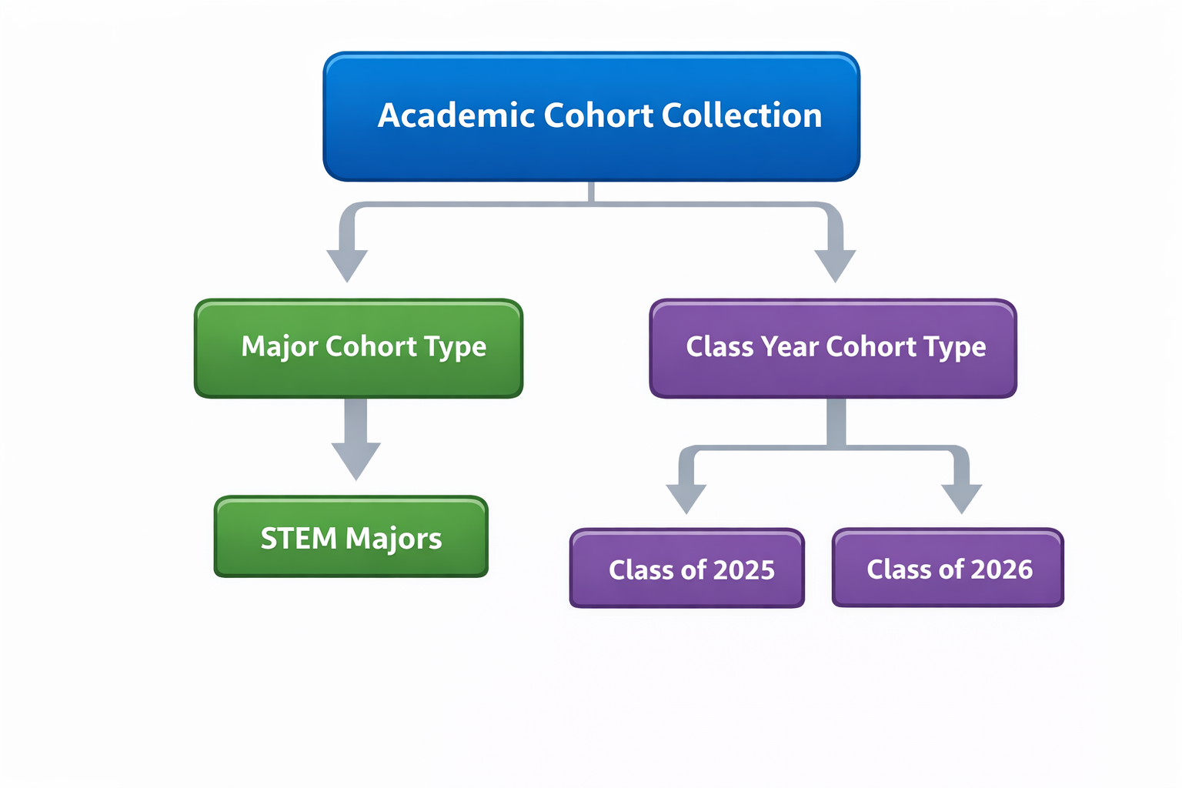

Create a Manual Student Cohort and Assign Advisors

These are the steps to create a manual student cohort. A manual cohort requires action to add or remove students. If you need to create a criteria-based cohort, click here.

- In another tab, it is recommended to open up the task Find Student Cohorts. Identify a cohort you want to use as a template to help you with formatting along the way.
- Access the Create Student Cohort task.
- Complete the required fields. (This is where having a template can be helpful to ensure your cohort set-up is consistent.)
- Once created, you may need to assign an advisor. In that case, select the Related Actions button next to the cohort name, select Roles > Assign Roles.
- Leave the effective date the current date and click OK.
- Select the Advisor type. Then in the Assigned To column, enter in the name of the person in the cohort.

Create a Criteria-Based Cohort
Before creating the cohort itself, you must first create a report that pulls the population of students that should be included in the cohort.
- Access Create Custom Report task.
  - Report Type: Advanced
  - Optimized for Performance: YES
  - Data Source: Academic Record
***If the report is not optimized for performance AND using the Academic Record data source, it will not be available for use in a student cohort.
- Input relevant fields and configure filters on the report. The filters must be hard-coded in the report.
- Next, access the Create Student Cohort task and fill in the required fields.
  - IMPORTANT: Make sure to select the “Criteria Based” AND “Updates Membership Automatically” checkboxes are checked. If the cohort is not updated automatically, the cohort can only be refreshed manually.
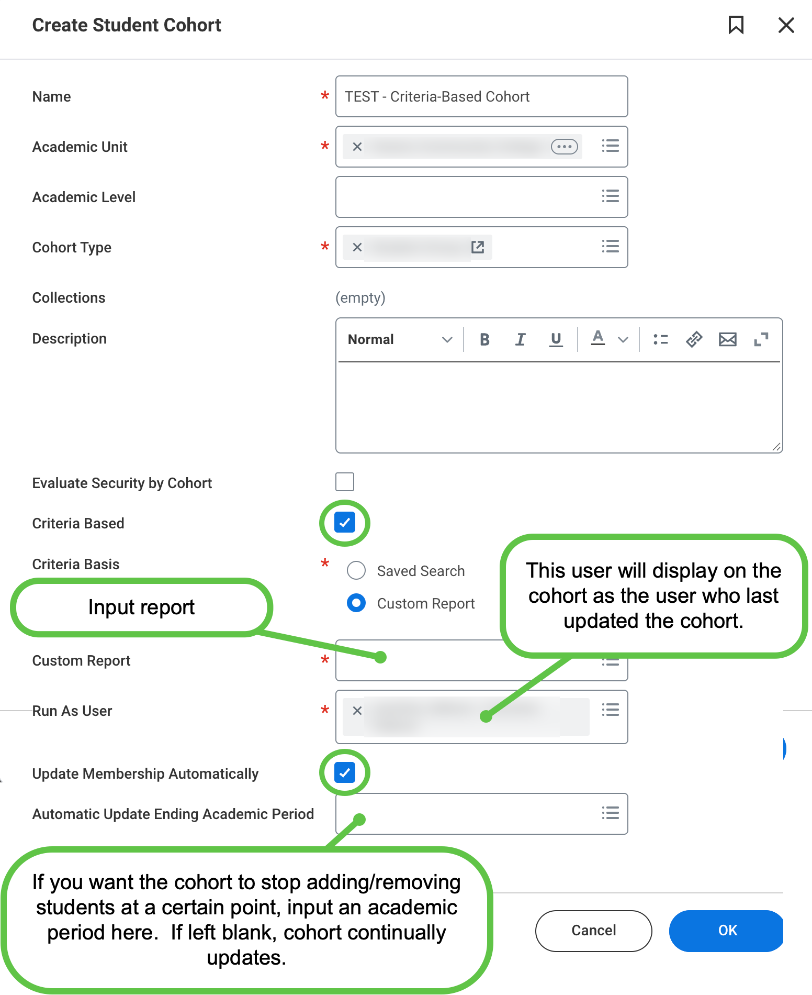
- Review the number of records that will be added to the cohort. Ensure that this appears accurate before checking Confirm and clicking OK.
  - If cancelled at this point, the cohort is not created and you must repeat all steps.
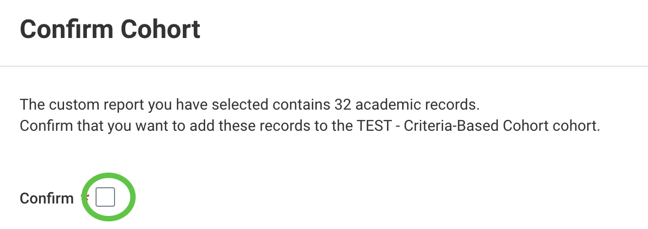
- Once complete, you can access the cohort to review the records that were added.
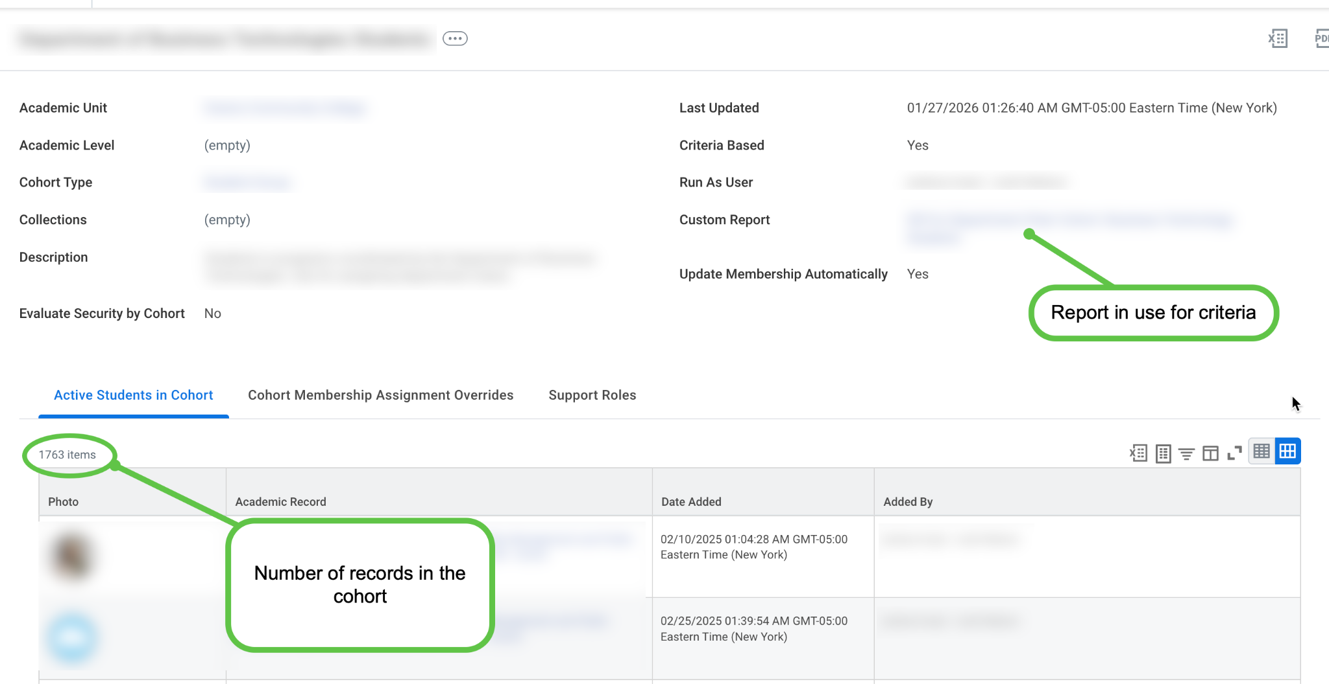
- NOTE: The cohort updates overnight. If there is a need to update the cohort more immediately, you can do so manually. On the related actions (from the cohort), select Student Cohort > Update Cohort Membership.
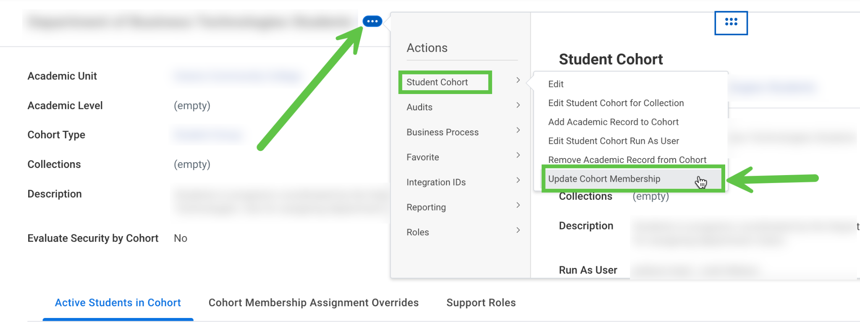

Extend Indexed Data Sources
If a field is not accessible on a criteria-based cohort due to it not being an indexed field, there is an option to “extend” the field, which then makes it available for indexing/including in a criteria-based cohort.

Information from Workday regarding background and set-up:
- Concept: Extended Indexed Data Sources
- Set-up Guide

Alternative Option: Boomerang Integration
If a field is not suitable for extending, an alternative is to create a custom report that includes the necessary fields and set up a boomerang integration. (It is recommended to fully review the extending option first, if this is a significant field that may be used frequently.)

Add Student to Cohort
To ensure accurate reporting of cohorts, students should be added or removed as of the Standard Start Date or Standard End Date, respectively.
- There are two ways to navigate to the Add Student to Cohort task. You can access it from the Workday search bar or directly from the student profile.
OR
- Access the related actions on the student profile (Actions button under student photo) and scroll down to Student Cohort > then select Add Academic Record to Cohort.
- On the task, select the student and the relevant cohort.
- For the Add Date, you can either select As of Now or By a Specific Date. Which date you use may differ depending on the type of cohort and how cohorts are being used.
  - If you select By a Specific Date additional fields will populate. Select the academic period from the drop down. In general, the Standard Start Date should be used if you want the student to display as in the cohort as of a specific academic period. (Selecting this option defaults that date into the Add as of Date field.)
  - IMPORTANT! If you see a Specify Override Type section, this indicates that you are adding a student to a criteria-based cohort. REVIEW YOUR ACTION. If the student is not an exception, cancel the action and update the cohort directly (click here for instructions). If it is a true exception, you may proceed with adding.
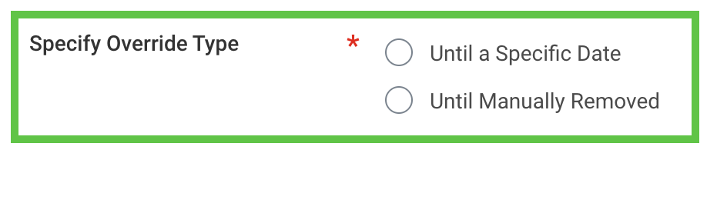
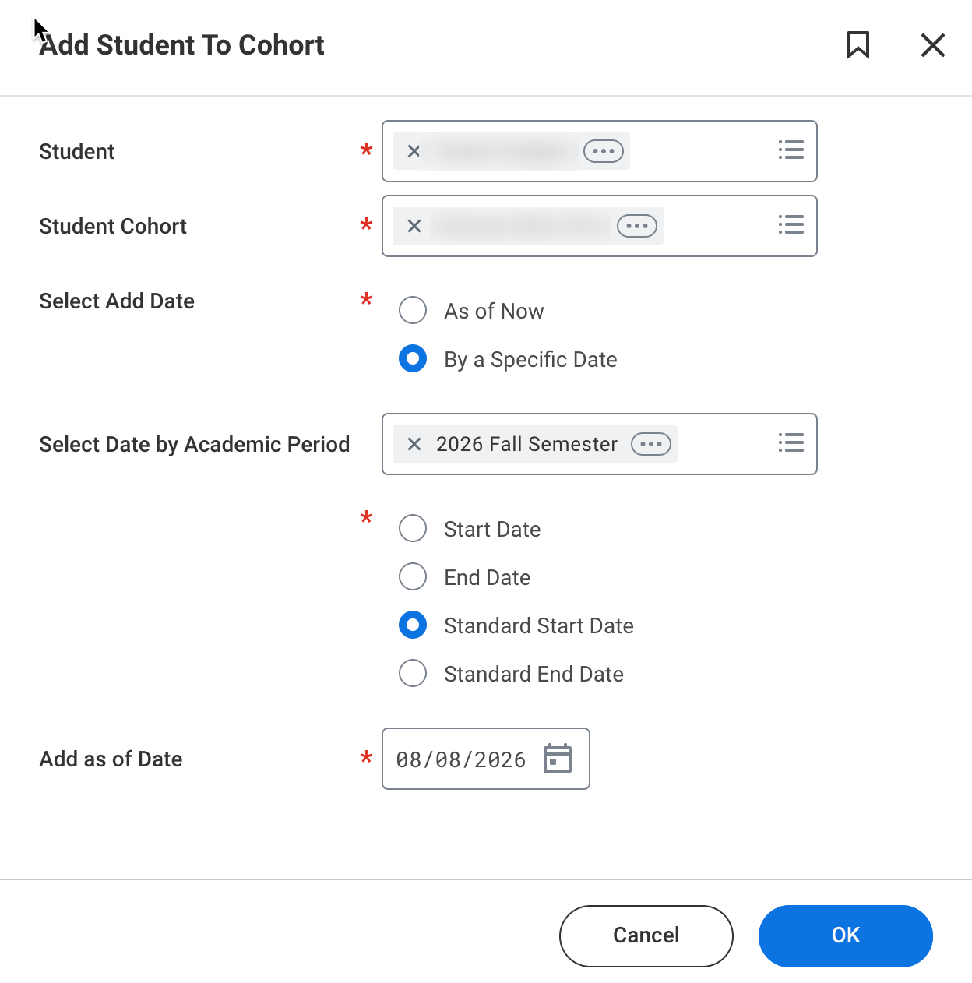
- Click OK.
- You can view the student in the cohort list by accessing Find Student Cohorts.

Add Multiple Students to Cohort
- To add multiple records to the cohort, use the Find Academic Records report.
- Filter to identify your target population as best as possible. You can select multiple filters.
  - NOTE: You cannot filter, select students, re-filter and continue selecting students. If you attempt to re-filter, the previous selections will be lost.
- Select students by checking the box next to their record. At the bottom, select the Add Academic Records to Cohort button.
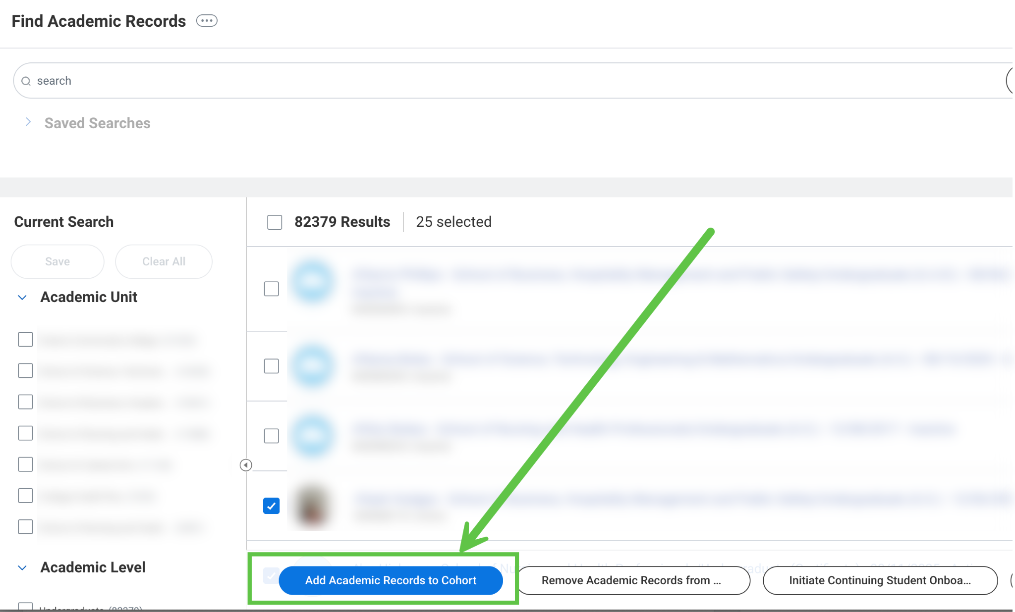
- Select the cohort to which you want to add the records. Select As of Now to add the students immediately, or select By a Specific Date to add the records to the cohort at a specified time.
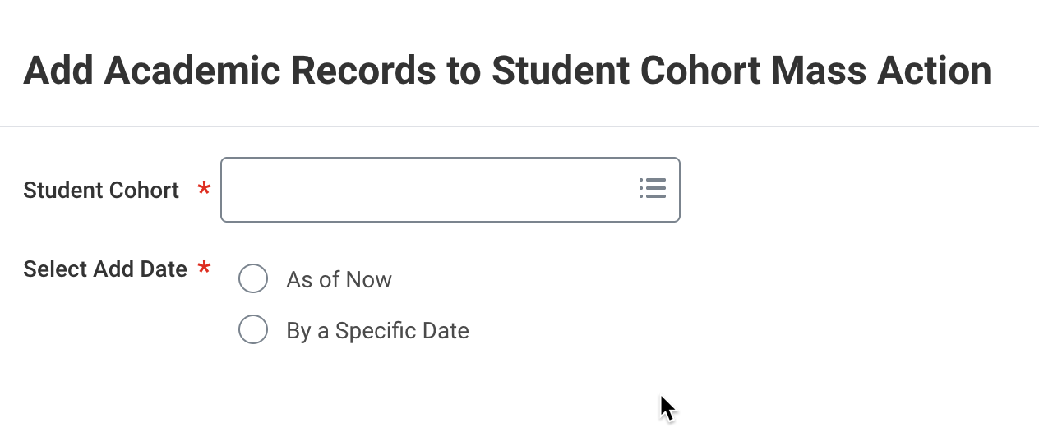
- You will receive a confirmation page. Depending on the number of records you are adding, it may take some time to process.
- To validate, navigate back to Find Academic Records report and re-filter by the cohort to ensure that all expected records display.

Remove Student from Cohort
- There are two ways to navigate to the Remove Student from Cohort task. You can access it from the Workday search bar or directly from the student profile.
OR
- Access the related actions on the student profile and scroll down to Student Cohort > select Remove Academic Record from Cohort.
- On the task, select the student and the relevant cohort.
- For the Remove Date, you can either select As of Now or By a Specific Date. Which date you use may differ depending on the type of cohort and how cohorts are being used.
  - If you select By a Specific Date additional fields will populate. Select the academic period from the drop down. In general, the Standard End Date should be used if you want the student to reflect as moving out of the cohort at the end of a term. (Selecting this option defaults that date into the Remove as of Date field.)
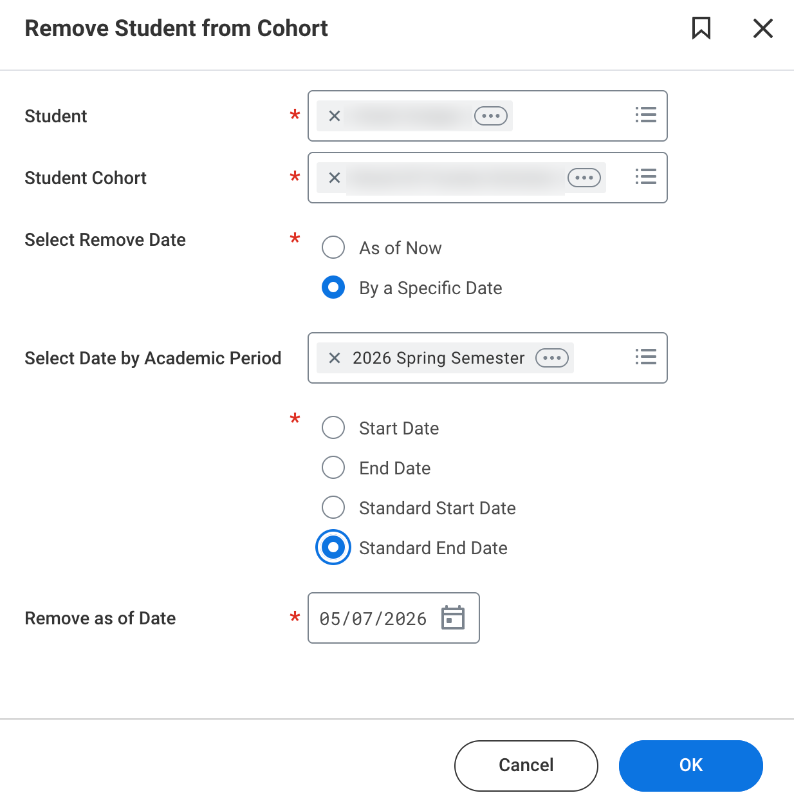
- Click OK.
- You can view that the student will be removed from the cohort on the future date (if applicable) by accessing Find Student Cohorts, selecting the cohort and clicking the Future Cohort Membership Assignments tab.

Remove Multiple Students from Cohort
- To remove multiple records from the cohort, use the Find Academic Records report.
- Filter by the cohort from which you are removing records.
- Review the results, and if appropriate, check the box at the top to select all. At the bottom click the Remove Academic Records from... button.
  - Alternatively, if not removing all students, select each student by checking the box next to their name.
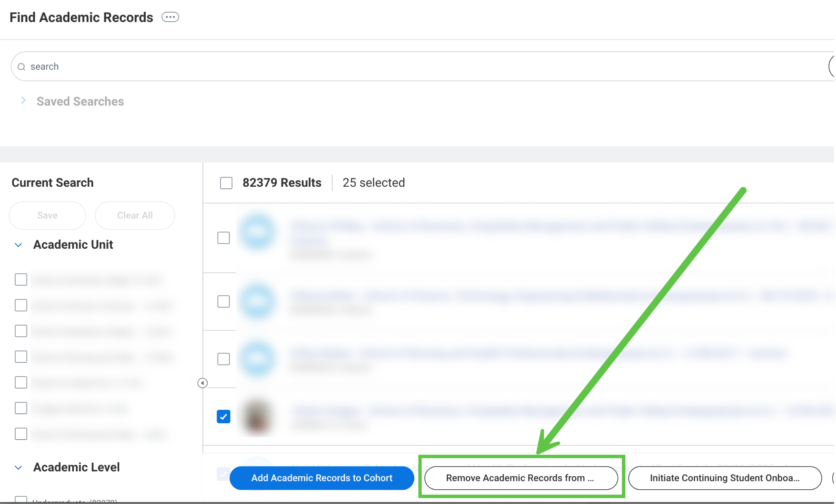
- You must re-select the cohort from which you want to remove the students. Select As of Now or By a Specific Date and click OK.
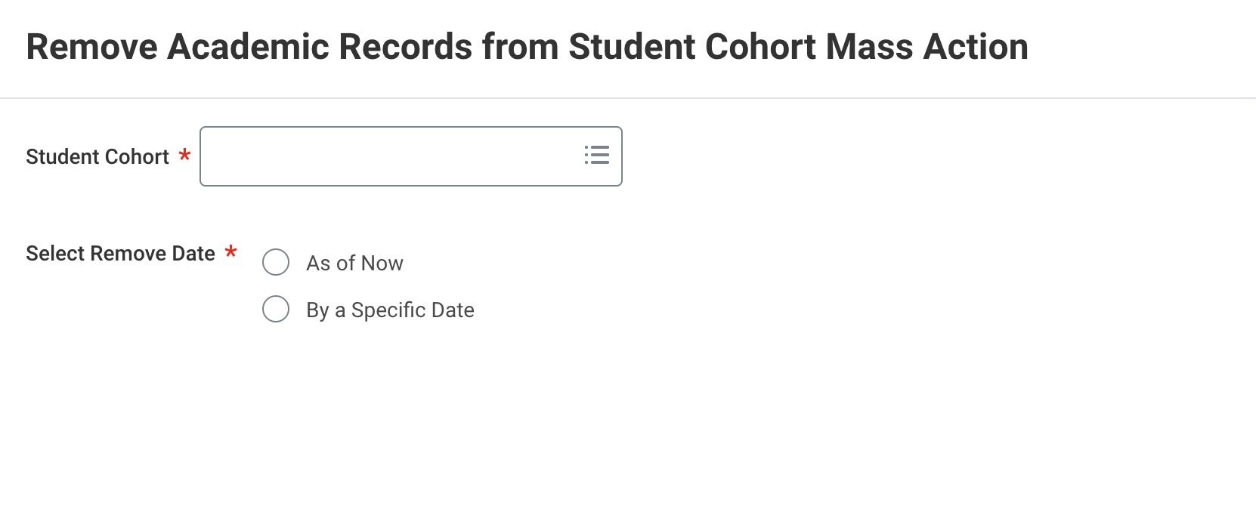
- You will receive a confirmation page. The removal may take some time to process.
- If you selected As of Now, you can navigate back to Find Academic Records report and re-filter by the cohort to ensure that no records display.

